Step: 1
Open Your Fiori App
Click on Register New Courses.
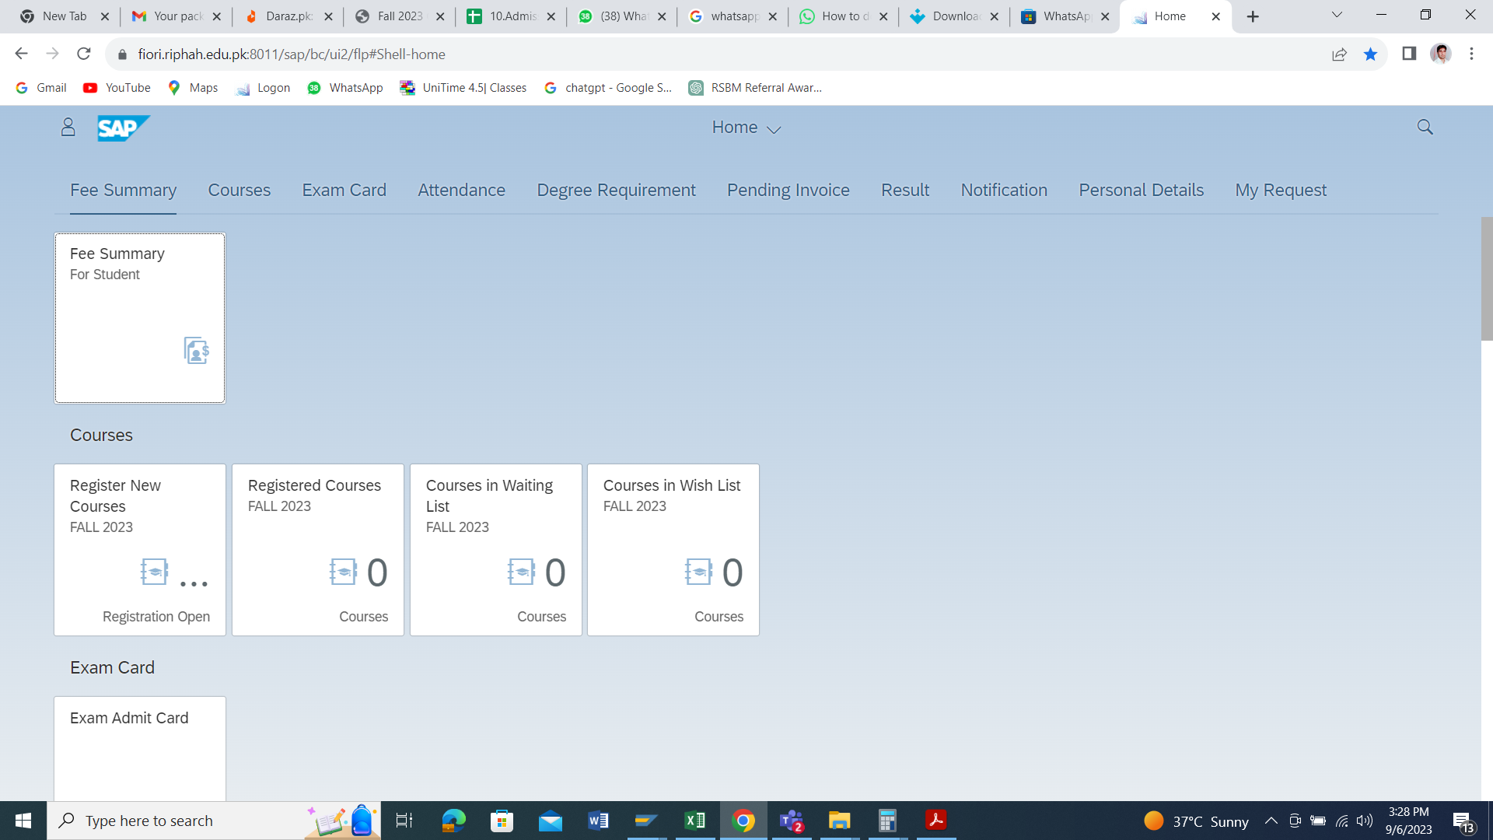

Step: 2
Select your correct Subject
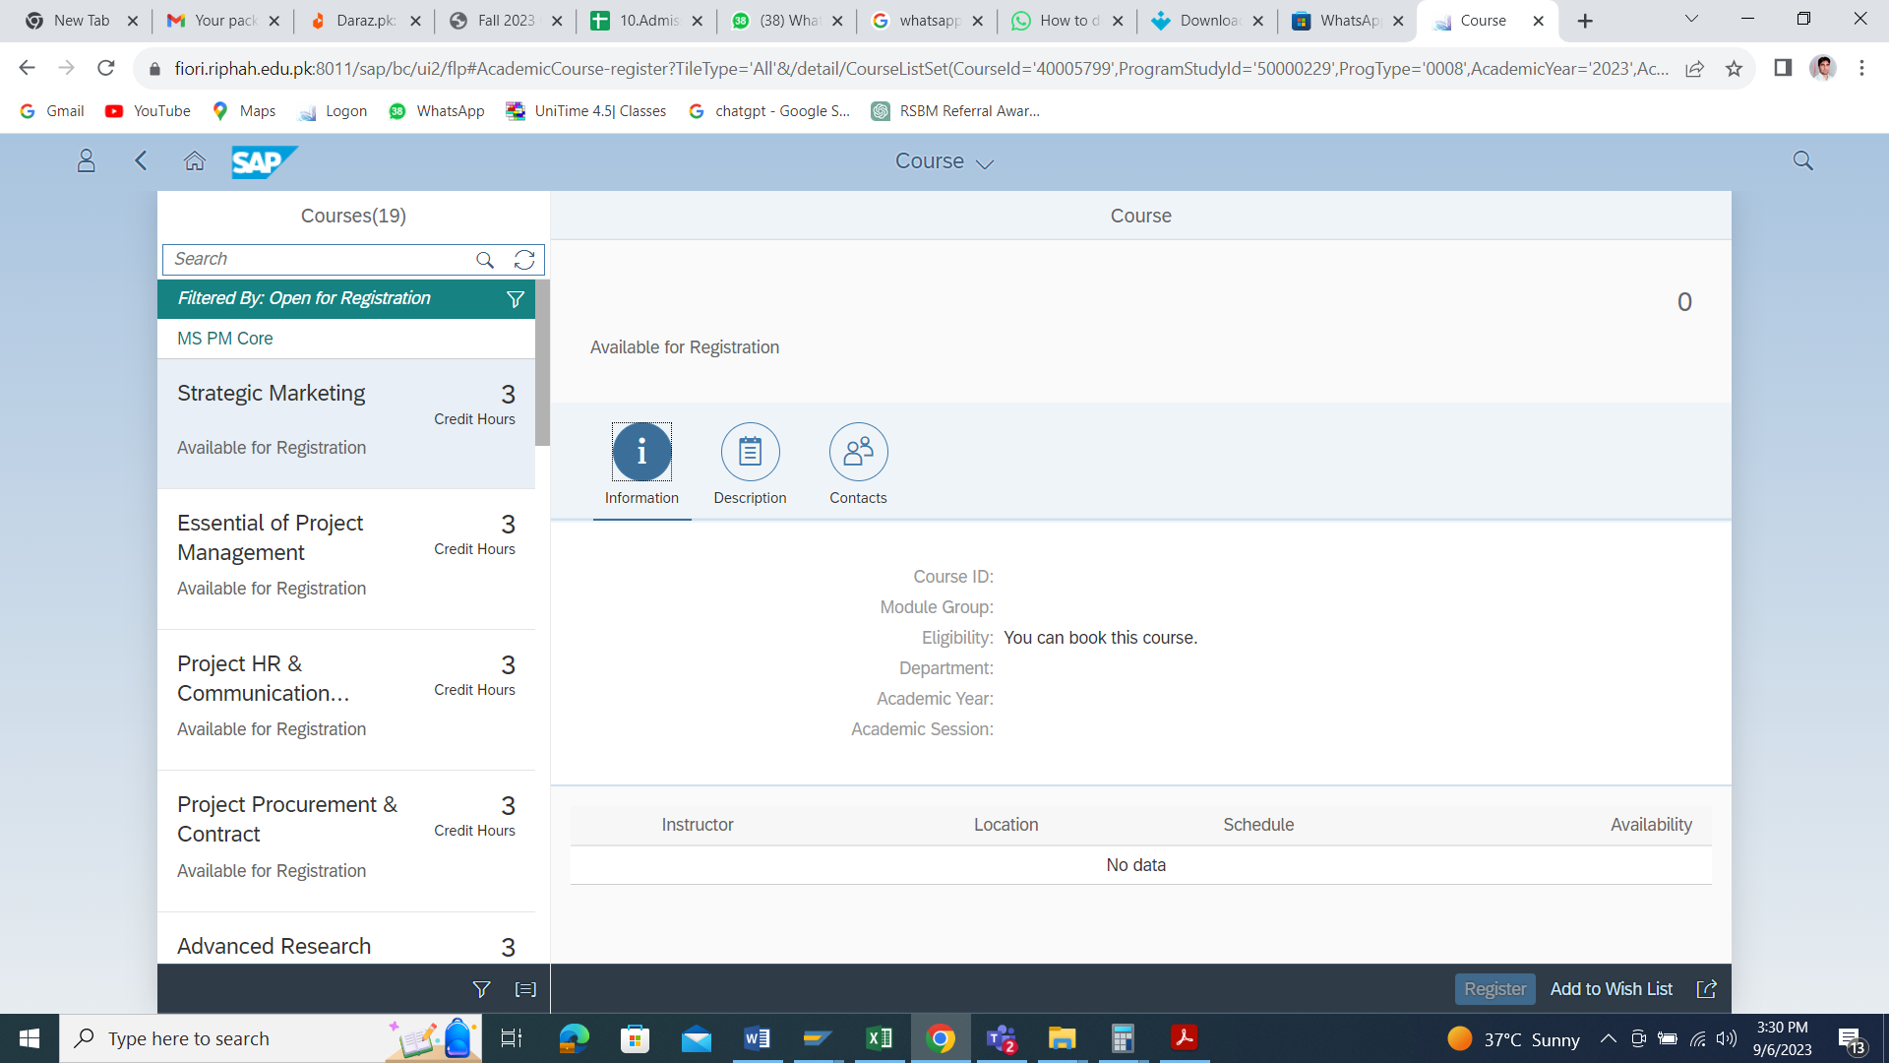

Step: 3
Kindly verify your program

Step 4:
Click the button below below the Theory

Step 5:
Click on Register button.
Note: Do Same for every Subject.

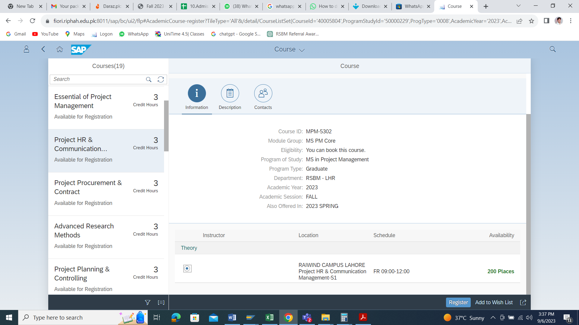

Step: 6
Verify Your Registered Courses
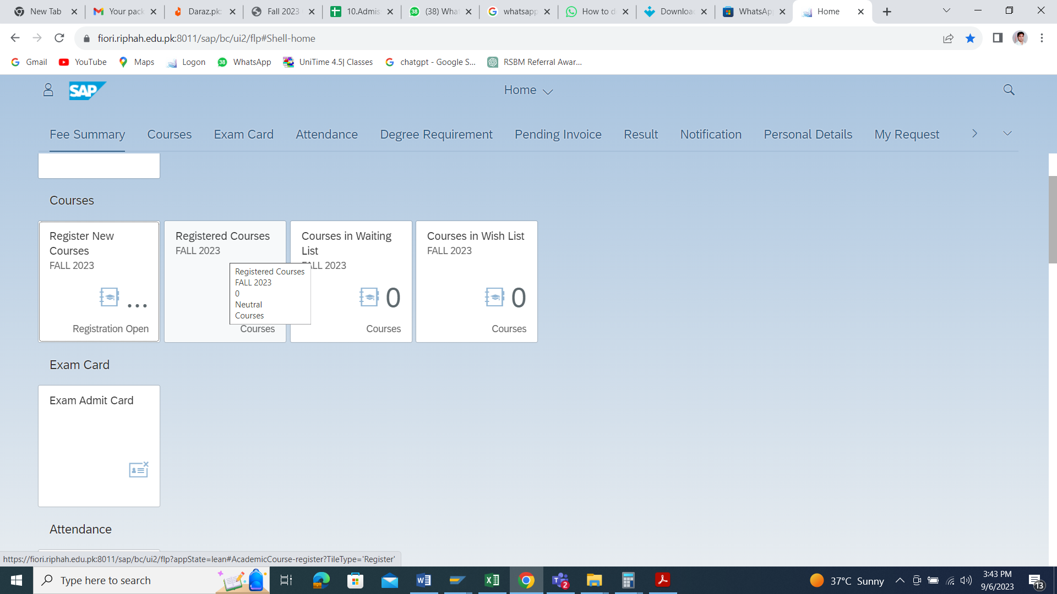

Step: 7
Download Your Fee Challan click on this button
Challan Will be shown after 24Hrs.
